ACJP implemented various skill development project from 2013 and continued in process for development. Some of the few activities briefly mentioned here and PAPs beneficiary through our project in Govandi area.

PAPs:The community belong to Socio-economical, educationally weaker section are most affected community settled in slum area of city , government acquired their land with forcefully evacuated their family from their houses for developing the infrastructural facilities in citiessuch so c project affected people (PAP)community ,resettled in new location.These communities have very few opportunities to earn their livelihood without having skills to support financially to the family.
ACJP created new enthusiasm among the women and girls child for skill development program. Our network of vocational training , adult literacy education, life skill development using practical tools started. Our effort to generated confidence, self determination to empowered women to face the financial and social challenges 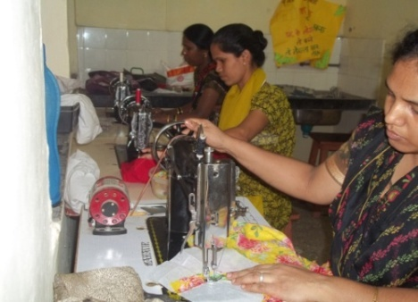
For Empowerments of women,we offer the vocational courses in Garment designing, tailoring, embroidery, Beautician training, spoken English and adult literacy educational program.
Presently 30 women’s and girls are taking the garments and tailoring course and 20 girls are in Beautician course in our vocational center. Trained women or girls have been acquired job outside employment and some women are working from home. With help of our networking with Kotak & Mehendra Foundation, have been offered three month skilled training in basic computer and retailers job,after training all have been got the job in shopping malls and retiles desk service billing job, nearly 15 girls are earning Rs. 8 thousand to Rs. 10 thousand per month.
Net working with Sahyog Trust who has give computer courses like MSCIT and basic computer courses where 30 girl taken the certificate course from our project .
SHG: We have also strengthen the Self Help group through training and motivated them to participate in micro financing project,Basic home budgeting , Saving , and managing the self finance, helping to each other . Total 10 SHG formed and provided training through BMC Corporation.
Adult Education : there are 23% house wives are illiterate and hesitated to join the Sarvshikshan Abhiyan scheme, our volunteer visiting their house and making exercise to learn the basic education, we use to conduct adult education classes twice in week , sixteen women has taken basic education and now they can make their own signature , read Marathi and Hindi .
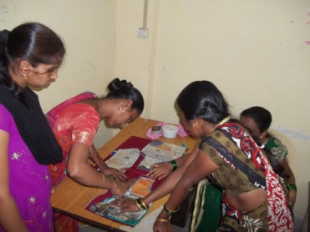

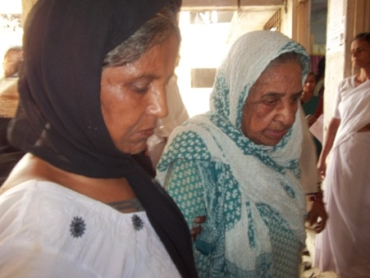

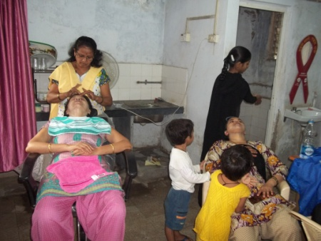

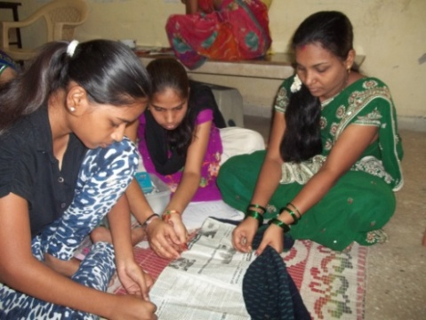

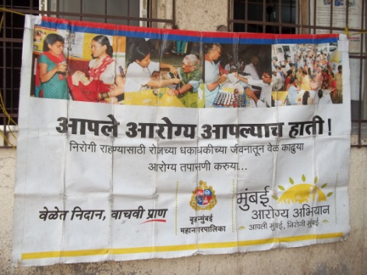
Health camp : Senior citizen and particularly women are facing various medical problem, they cannot afford medical treatments and most of the cases they adopted non medical practices , therefore we organised the various medical camps , eye camp, gynaecology camp paediatric and general medical checkups to screen the health of theses community.
Our network provided free cataract operation last year we have done 5 free cataract operation through Laxmi Eye charitable trust Panvel. A free medical checkups and provided low cost generic medicine to needy people. Dr Mahatme Eye Hospital Mulund , Dr. Gaware Narshing Home, Govandi, BMC Hospital and health deportment of M-E ward , Chembur are provided their service to theses community .
Drop-in Center for poor:
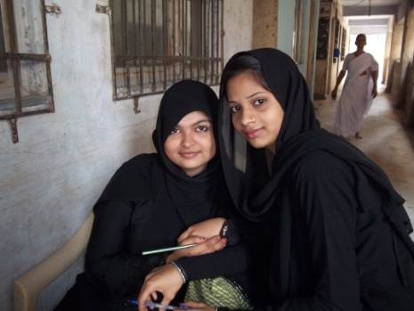
ACJP started a drop-in center for project affected people and rehabilitated resettled colony in Govandi. The various Health camps
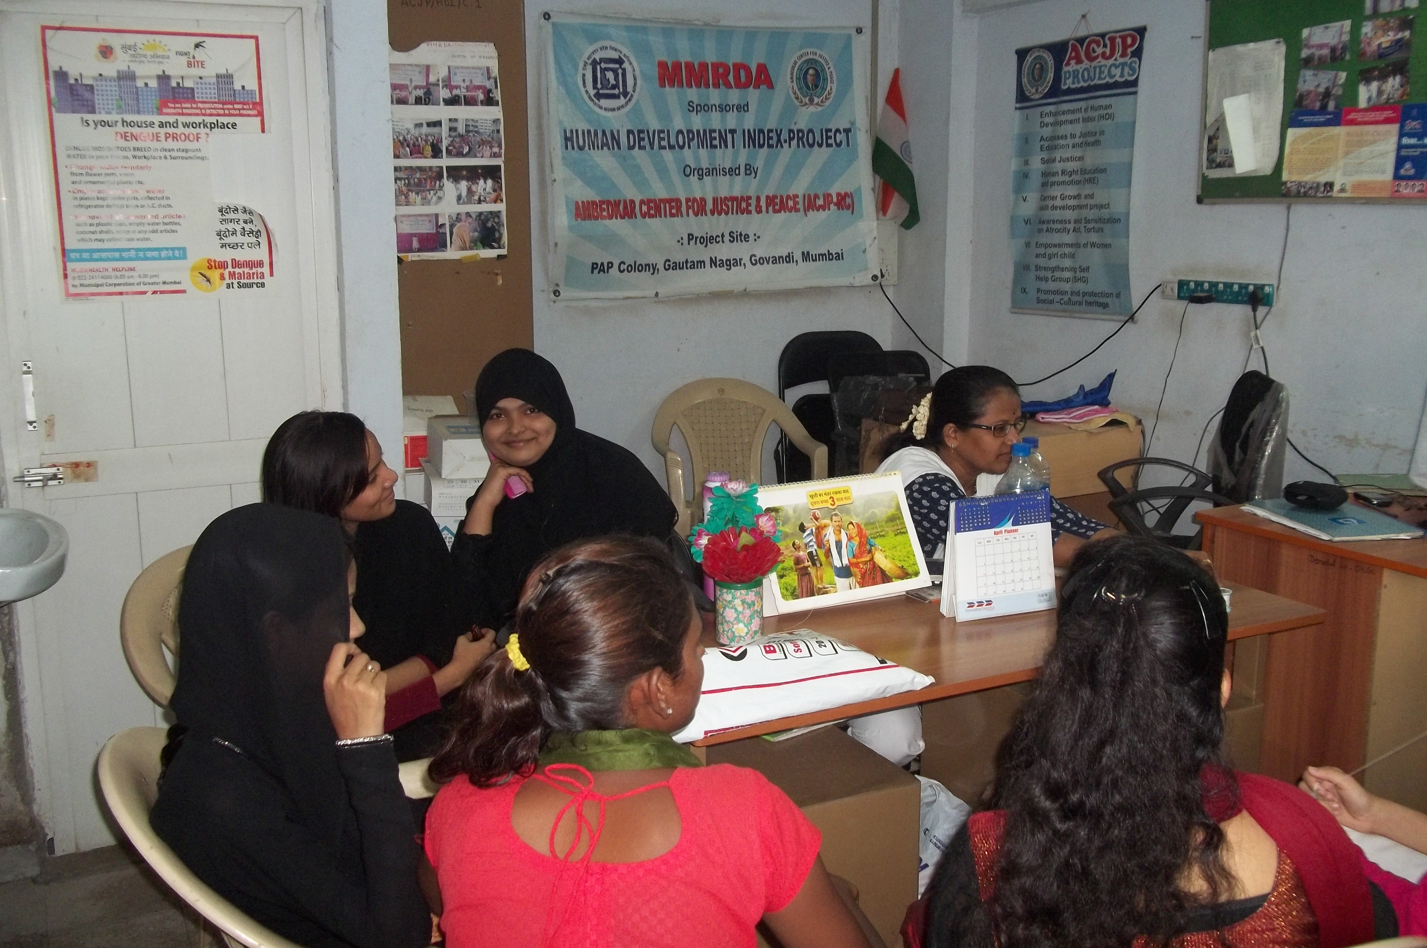
and vaccination camps as per the government policy /scheme, This center also provided DoT treatment for eradication of TB and camping for various Nation health program. We have facilitated DoT medicinethrough BMC hospital M-E ward and 36 TB patients cured completely after taking and follows up of six month course .
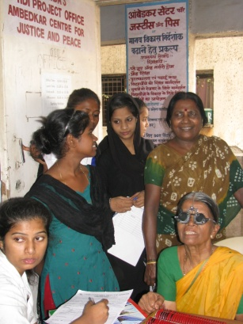
( Eye Camps supported by Laxmi Eye hospital Charitable trust Panvel )
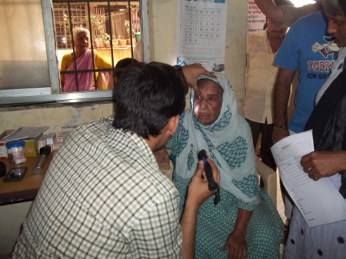
Formal education, special coaching classes for weaker student , and non formal education for dropouts with special attention and encourages to bring them in to main stream of education. The play home and pre nursery home for kids , whom mother are engaged in house making work , we have enrolled such 30 kids in our play home and later on they admitted in regular school in 1st standard.

Reading Room & Library: We provided study room cum library for the student and students are taking benefited fromthe library
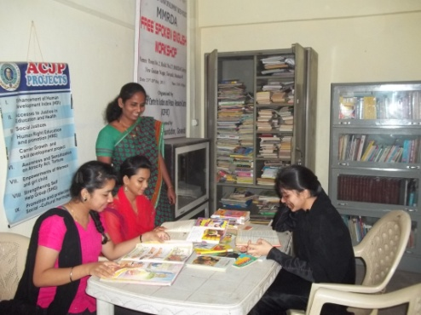
Cultural Event : we also organise the student get together and educational activities , motivational ,program on enjoinments, health hygiene, personality developments , social science etc. The best student in colony awarded in public function.

